**Notes App user guide**

|  |
| --- |
| Akrivi Grigoropoulou |
| Evgenia Ioannidou |

**LOG IN OR REGISTER**

First of all you have to run **localhost:3000**

And this page shows up:

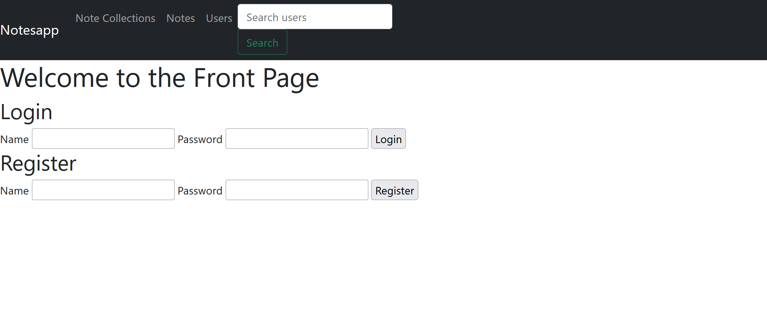

To the home page in order to register or to sing up

**NOTES**

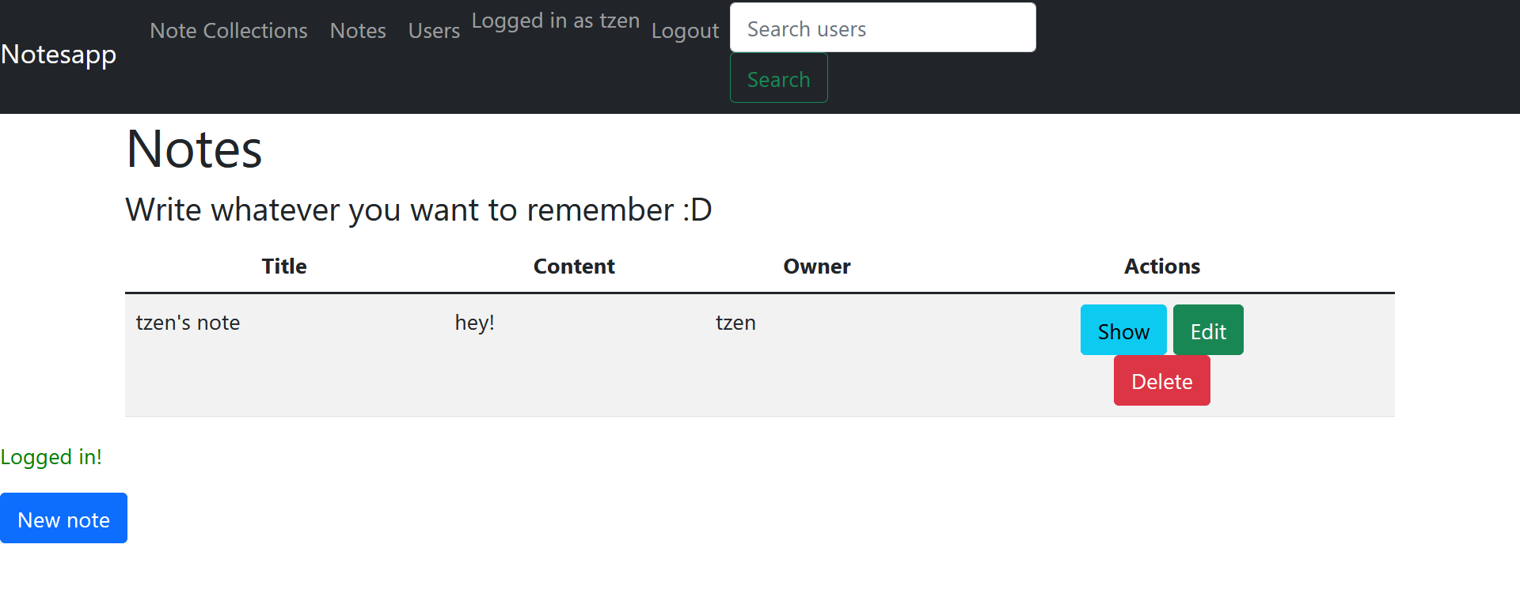

Then it shows you your notes

Now we already have create some notes

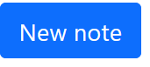

In case you want to create a new one, you just have to click on the button

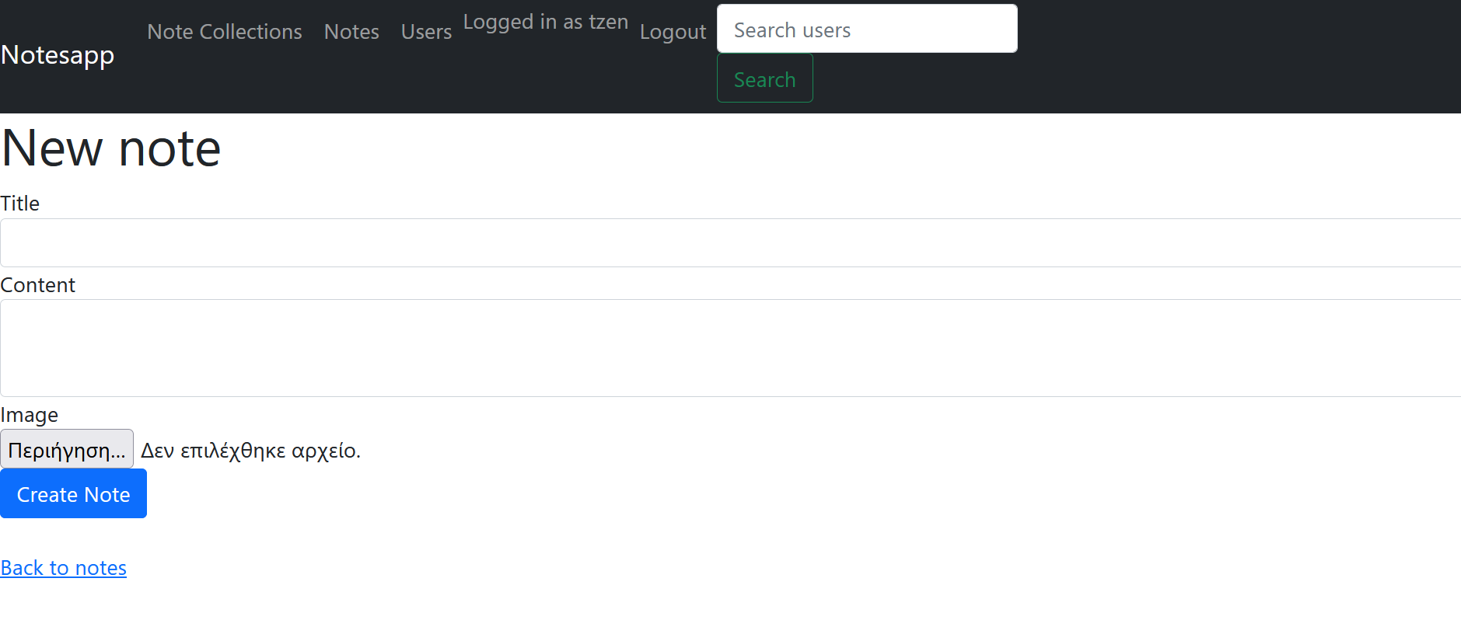

And this window shows up. Now you can create a new note

* You can also add an image if you want with the button “choose file’’
* When you have create your note, you just have to click on the button “Create Note” in order to save yours.
* To go back to the list just click on “Back to notes”. It takes you back to the first page

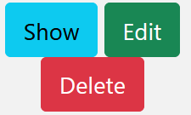

You can see your full note if you want, just with a click on “Show”

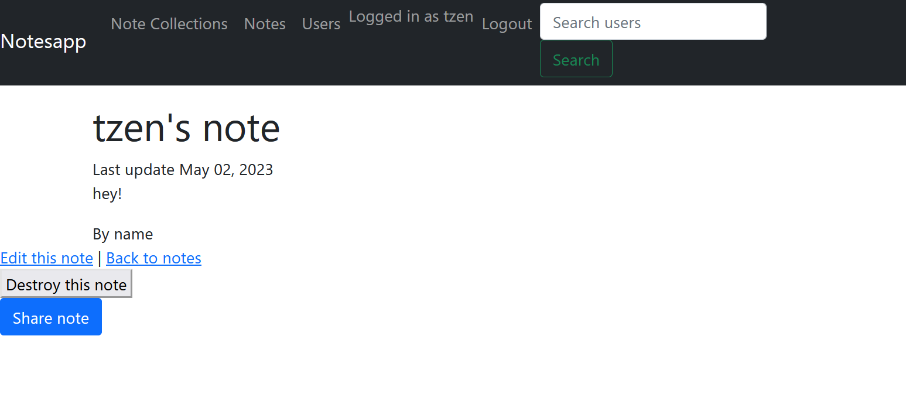

Your note shows up.

* If you click on “Back to notes” it takes you back to the list of your notes
* If you click on “Destroy this note ” the note that you choose will be deleted and this massage will show up with the new list of notes

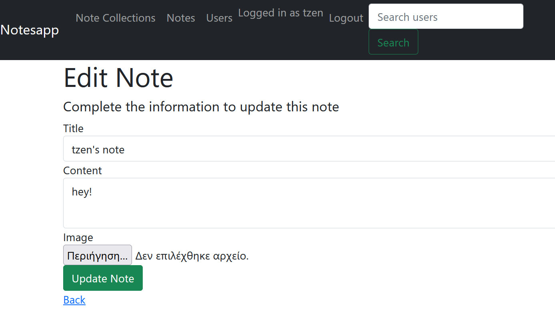

You can also separate click on the button ‘Edit’ to edit the notes

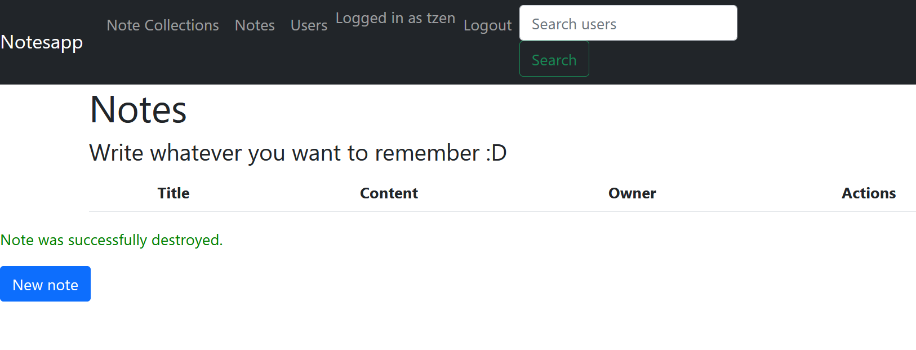

Last but not least you still can Delete the notes from the start screen with the button “Delete”

**COLLECTIONS**

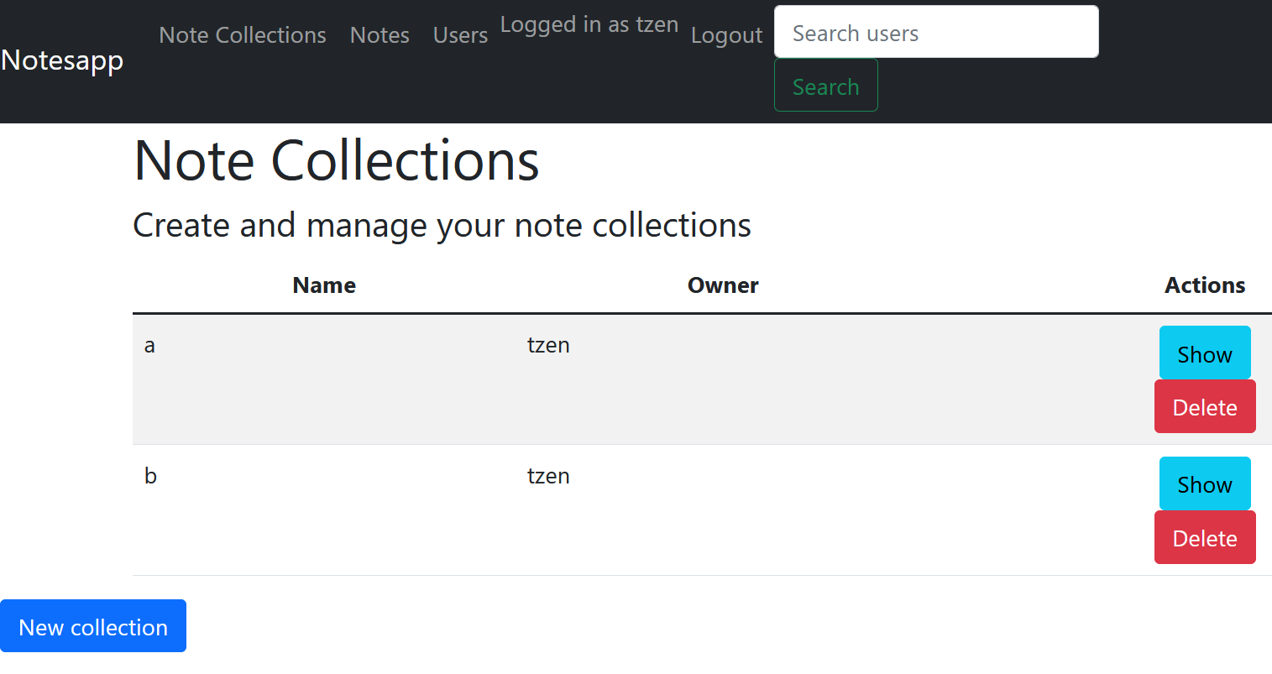

You can go to the note collection page by clicking on the navigation. The list of your note collections appears. You can create a new collection by clicking in the blue .

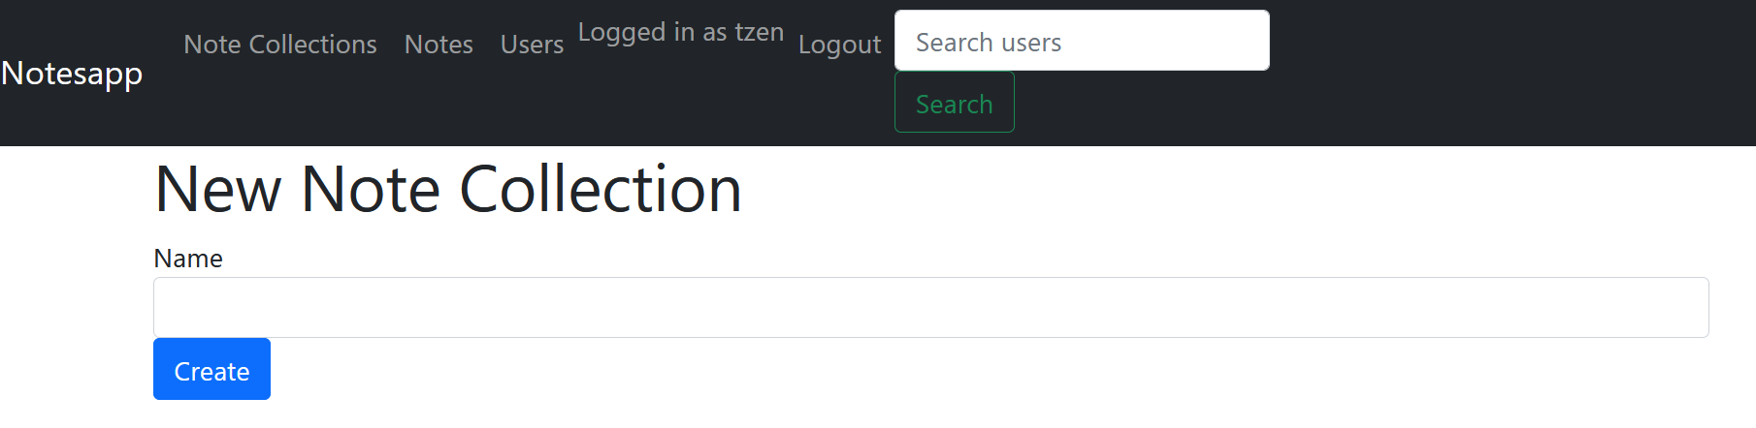

This page appears where you write the name and your submitted by clicking create.

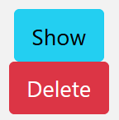

By clicking so a new page appears where you have a list of all the available for adding nodes. If a note is already on this or an other collection, it won't appear here.

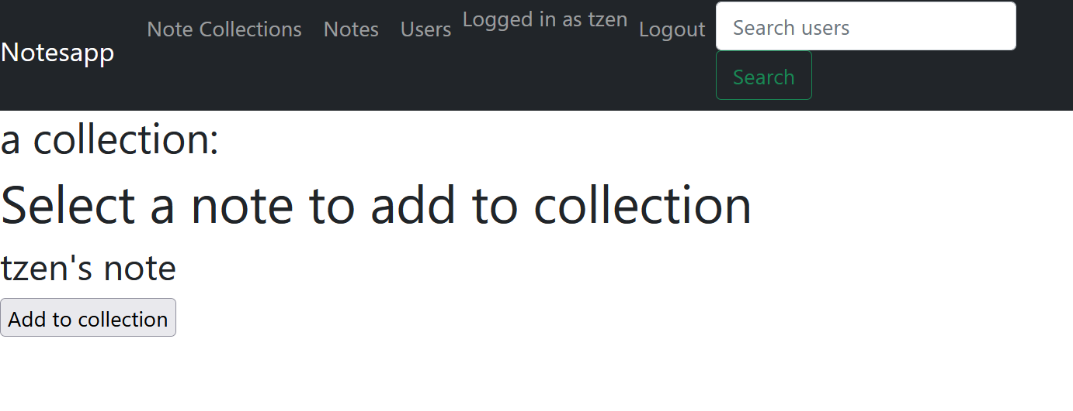

By clicking on the delete button the note collection he's being deleted.

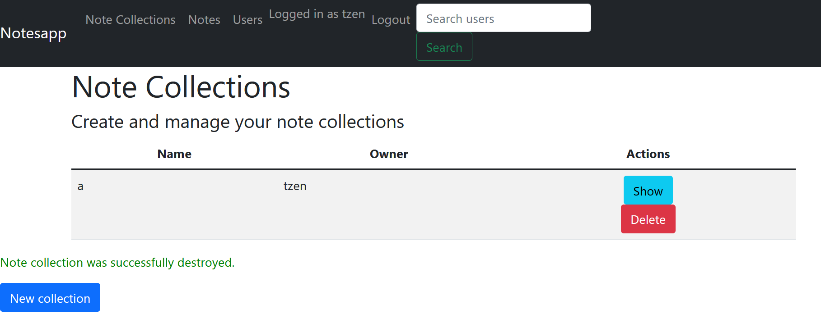

**ADMIN**

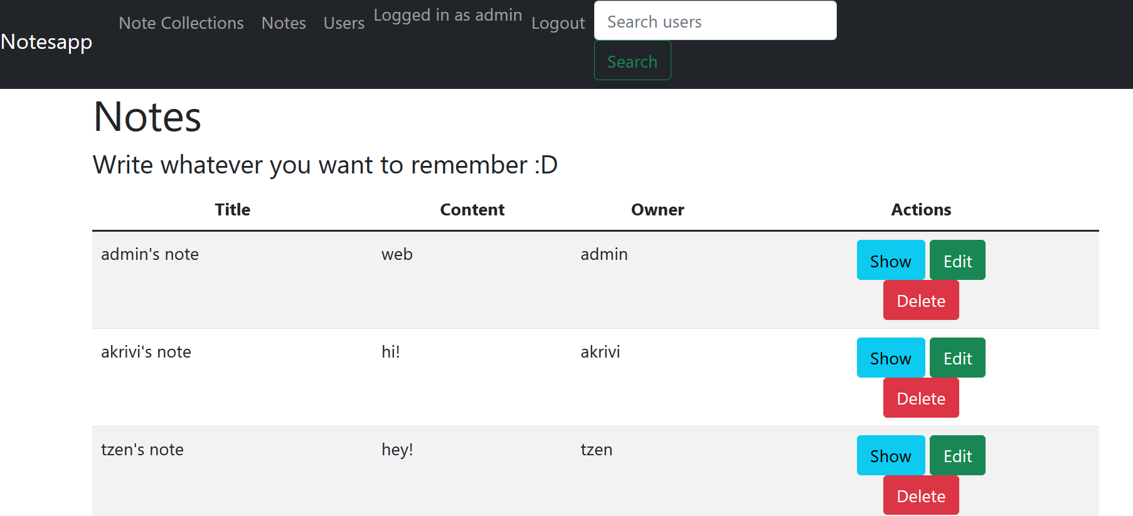

Each user has access only to the note he has created, besides admin that can fully access and manage everyone's notes. He's the only one who can add all the notes to his collections.

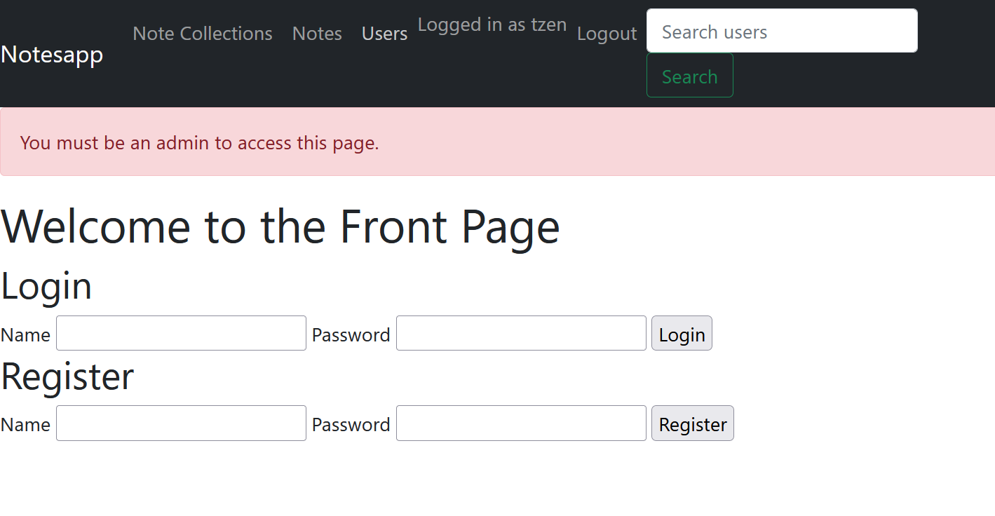

When trying to access the users page, you get this message if you're not logged in as the admin.

**USERS**

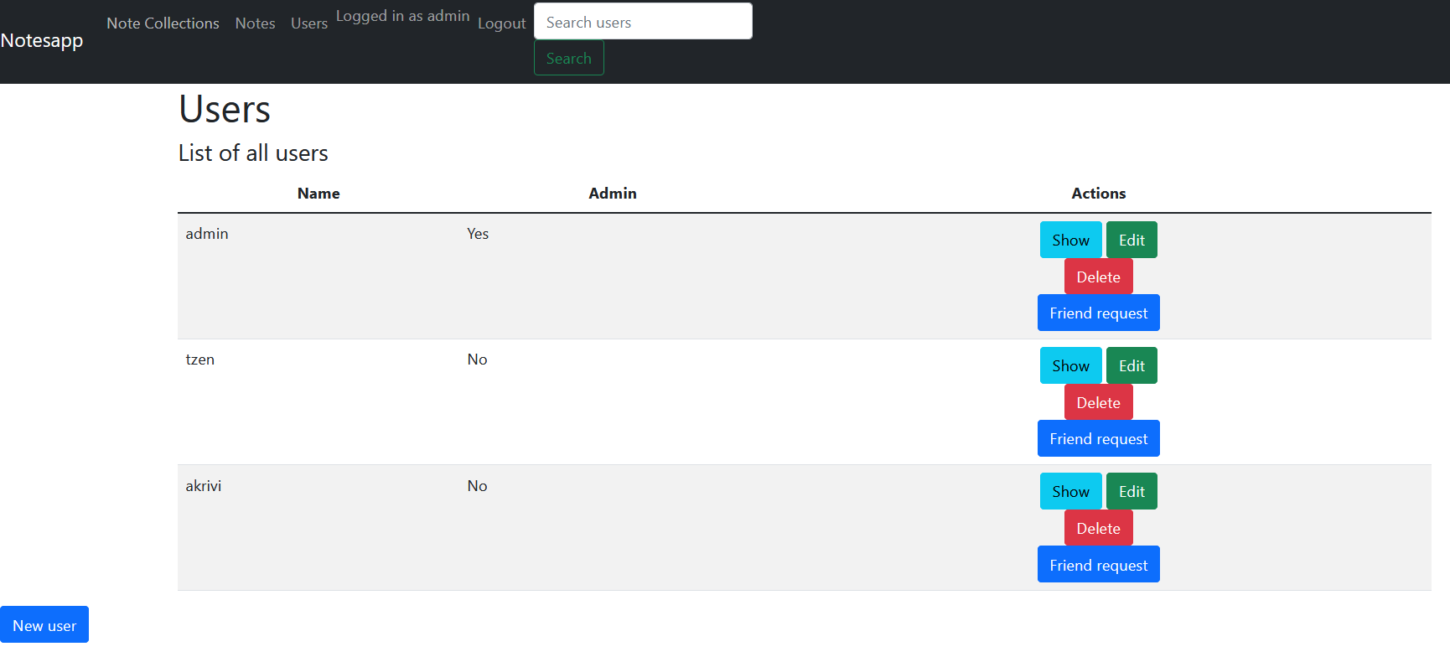

Being the only one with access to the user page, admin can view the list of all users.

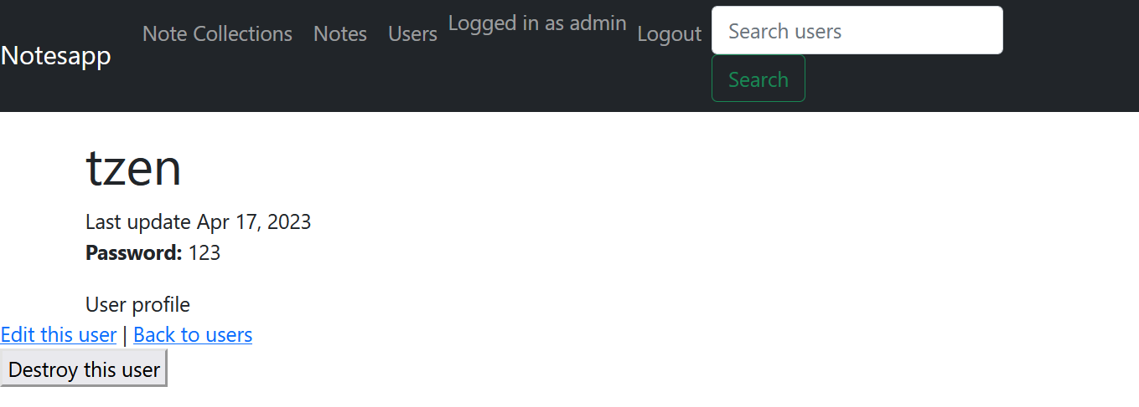

With show the user profile page comes up.

* He have the choice to edit it with a click on ‘Edit this user’ button
* If he clicks on “Back to users” it takes him back to the list of users
* If you click on “Destroy this user” the user that you choose will be deleted and a massage will show up with the new list of users

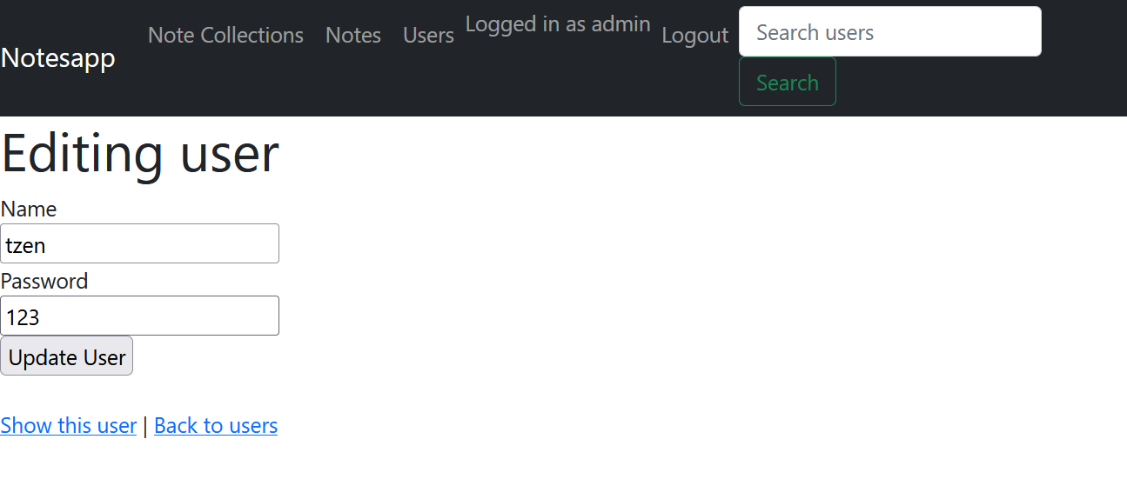

By clicking friend request, a friend request is sent to the other user.

**SEARCH USER**

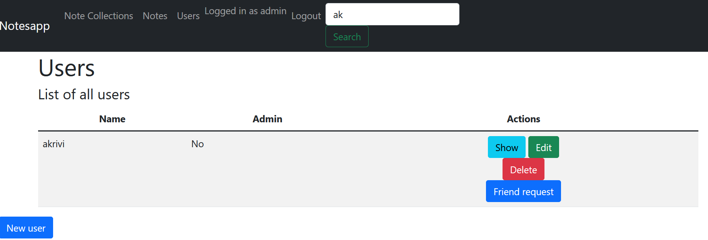

Also it is possible to find the user you are searching for from the search.

**LOG OUT**



When you click log out, you exit your account and return to the front page.